Week 8 Report

Some modification to the GA

37237256 薛丁銘

This week’s assignment was to complete the generation algorithm taught in the class. I did some modifications and experiments. Now I would like to introduce the code.

Firstly, the gene pool was generated as in Figure 1. The population size was also settled to 10. The gene pool was generated by ASCII code.

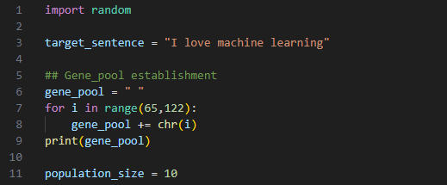

Figure 1. Gene pool establishment

Then, the functions of generating chromosomes and calculation of fitness were created as shown in Figure 2. I also made a function for calculating the fitness of the whole population.

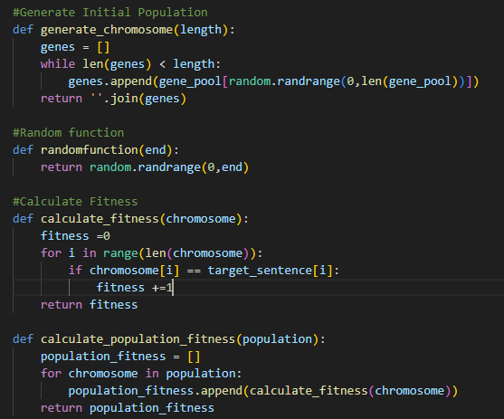

Figure 2. chromosome generation and fitness calculation

Then I added crossover functions. The idea was to select two healthiest parents for crossover. I also made a function of selecting two unhealthiest chromosomes for cleaning the population. The code is as shown in Figure 3.

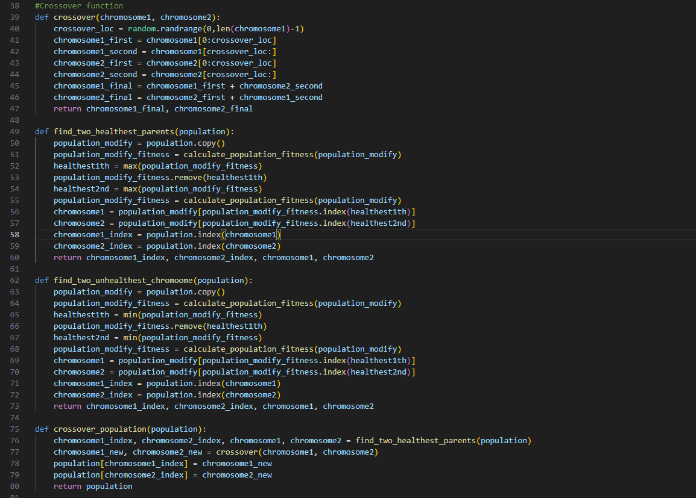

Figure 3. Crossover code

Next comes the mutation. The mutation consists of two parts, the mutation of the chromosomes and the possibility of mutation. The code is as shown in Figure 4.

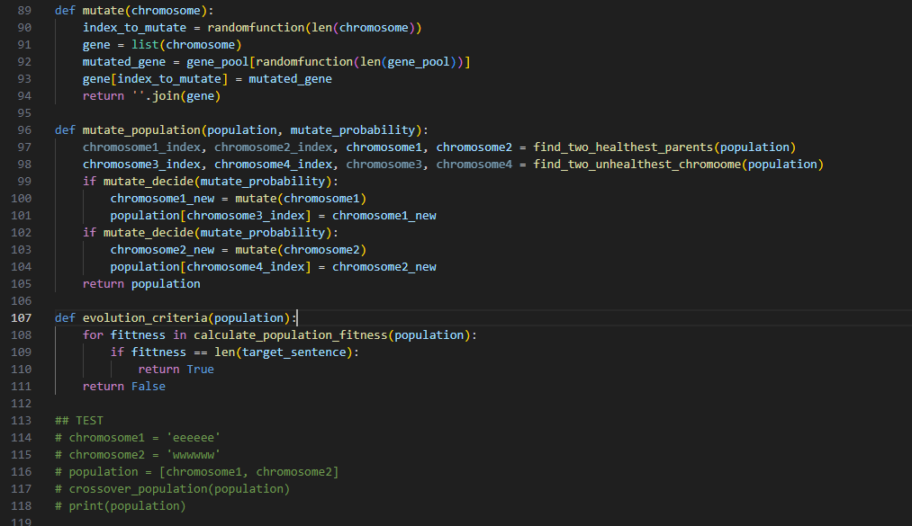

Figure 4. The mutations

Finally, it comes the generation code. Because I have made the functions in detailed, the generation function seems to be very simple as shown in Figure 5.

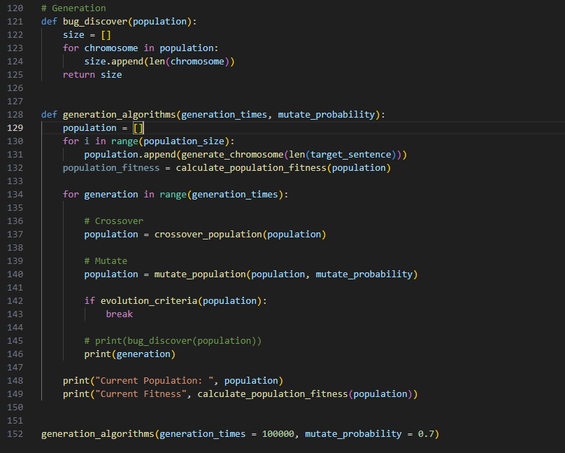

Figure.5 Generation code

I set the generation times to 100000 and usually the mutation stops as 3000-6000 times of generation. Figure 6 shows one of the generation results.

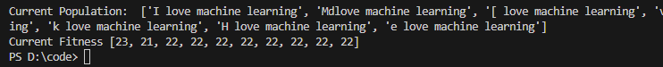

Figure.6 Generation result

We can find some interesting results that usually when the code reaches the criteria, all populations are almost similar to the target sentence.

With the increase of the length of the target sentence, we can see that more generation times are required as shown in Figure 7.





Figure.7 result with longer target sentence

I also adjusted the mutation possibility. The conclusion is that with lower mutation possibility, the generation time extends as shown in Figure 8.



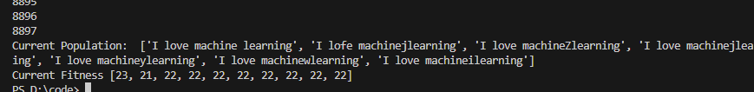

Figure 8. result when mutation possibility is low